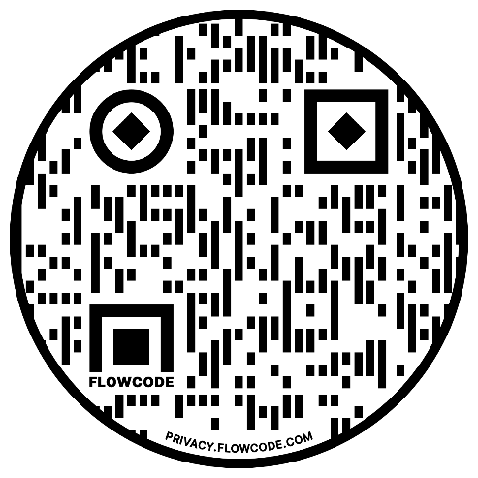



**East Riding Survey**

**How has Covid-19 affected young people and youth services?**

**Are you a -**

* **Young person**
* **Someone who works (paid or unpaid) with young people**
* **Parent or Carer**

**We need your views to understand how COVID-19 has affected young people in East Riding, as well as those services and people who work with them.**

**Have your say and take 10 minutes to complete our survey.**

[**https://ervas.org.uk/east-riding-youth-provision-survey/**](https://ervas.org.uk/east-riding-youth-provision-survey/)

**Follow the link above or scan the QR code below.**