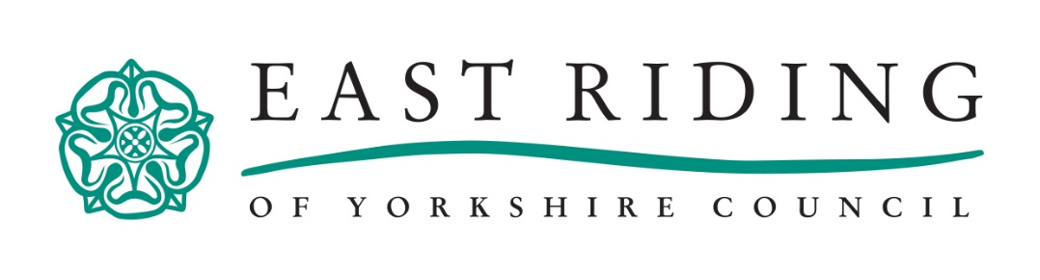

Climate Change Questionnaire:
Introduction:
What changes would you like to see in your community to fight Climate Change? Your ideas will help to shape our Climate Change Strategy.
Climate Change has become a Climate Crisis. East Riding of Yorkshire Council is committed to taking action at a local level to reduce our carbon emissions and create a healthier, safer, and more sustainable future for all.
The questions we have put together aim to build a better understanding of your thoughts and views on climate change. At this stage, we are seeking feedback and ideas only. As our Climate Change Strategy develops, there will be more opportunities to share your views. We look forward to hearing what you have to say! We are collecting this data anonymously, so please do not include your name anywhere on the questionnaire.
To align with our aims of becoming more sustainable, we are encouraging as many people as possible to complete this questionnaire online at: https://climatechangeeryc.commonplace.is/. However, to ensure accessibility to all residents across the East Riding, at the request of Councillor Chris Matthews, Portfolio Holder for Environment and Climate Change, a small number of printed questionnaires are being made available on request at East Riding libraries and customer service centres. You must be over the age of 13 to complete this questionnaire.
If you have any questions, or would like to discuss this questionnaire in more detail, you can email the Climate Change Team: climate.change@eastriding.gov.uk or call us on: (01482) 391758

- How concerned are you about Climate Change? (Please circle)
Very concerned Fairly concerned Unsure
Not very concerned Not at all Concerned
- How much do you think climate change is currently affecting the East Riding area? (Please circle)
A great deal To some extent Not too much
Not at all Don’t know
- Please number rank these options based on who you think has the most responsibility for tackling the effects of climate change in the East Riding area: (1 = Most Responsible; 5 = Least Responsible):
Local Authorities ……
Residents and Communities ……
National Government ……
Businesses ……
Industry ……
- Do you have an idea or suggestion for tackling the Climate Crisis in the East Riding? If so, please comment what this is:

- Is your idea related to a specific location in the East Riding? If so, where is this? If not, please just write “general area”:

- Which of the following climate priorities does this idea address? (Please circle all that apply):
Industry Waste Buildings and Homes Energy Supply
Trees and Green Spaces Community Action Transport and Air Quality Financing Agriculture and Food
Other:

- Which of the following would be needed to make this happen? (Please circle all that apply):
Community Involvement Skills and Training Education and Awareness Transparency Funding Political Leadership Fairness and Equality
Other:

- Do you have any further comments?

_____________________________________________________________________________________
Please tell us about you:
Knowing a bit more about you will help us to better understand why you are contributing. This information is optional and can only be seen by the project team. It won’t be public. You can change your mind about any of these answers by emailing the East Riding of Yorkshire Council Climate Change Team – climate.change@eastriding.gov.uk, or by calling us on: (01482) 391758

- What is your postcode?
- What is your connection to the area? (Please circle):
I live here I work here I study here I own a business here
I commute through here Other:

- Are you? (Please circle):
Male Female Transgender Prefer not to say
- Please indicate your age group: (Please circle):
13-17 18-24 25-44 45-64 65-74 75-84 85 years old or over Prefer not to say

Please help us reach all the community:
East Riding of Yorkshire Council would like to hear from all the community. We can only do this if you help us by providing information about your background. If any group in the community is under-represented, we can initiate other outreach activities to ensure they are heard. The answers you provide here are considered to be ‘special category’ data and, like the questions above, are optional. You can answer all the questions, some, or none of them. Your answers are anonymised. This means it cannot be linked to you. If you are happy to assist us by providing some or all of this data, please complete the questions below:
- Please state your sexual orientation: (Please circle):
Heterosexual/Straight Gay/Lesbian Bisexual Prefer not to say
Other:

- What is your ethnicity? (Please circle):
White (inc. Gypsy/Irish Traveller/Roma) Black/African/Caribbean/Black British Asian/Asian British Mixed/Multiple Ethnic Groups Prefer not to say
Other:

- Please state your religion or beliefs: (Please circle):
Christian Buddhist Jewish Muslim Sikh Hindu
Not Applicable/No Beliefs Prefer not to say
Other:

- Do you consider yourself to have a disability? Note - The Equality Act 2010 considers a person to be disabled if they have a “physical or mental impairment that has a substantial and long-term adverse effect on their ability to carry out normal day to-day activities”. You do not need to be registered disabled.
Yes (please state):
I need adjustments (please state):
No
Prefer not to say
Other:

